Ipsum Group Limited

Rochester House

Ackhurst Business Park

Foxhole Road

Chorley

Date: TBC

**Unlooping works taking place in your area**

Dear Resident,

We’re writing to you to introduce ourselves and inform you of electricity works that are due to take place in your area.

We are Ipsum, a trusted delivery partner and principal contractor working on behalf of Electricity North West to ’unloop’ your electricity supply. We are a business that specialises in infrastructure improvements, ensuring that the electrical networks that power your homes are upgraded efficiently, with minimal disruption to you and other residents, and with everyone’s safety as our top priority.

**What are unlooping works and why are they happening?**

Unlooping is a specialist process undertaken by electricity companies to provide each household with its own dedicated power supply. Some older properties were built with a ’looped’ electricity supply, where it is connected to the property next door. At the time of the build, it was easier and more cost-effective to install power supplies this way.

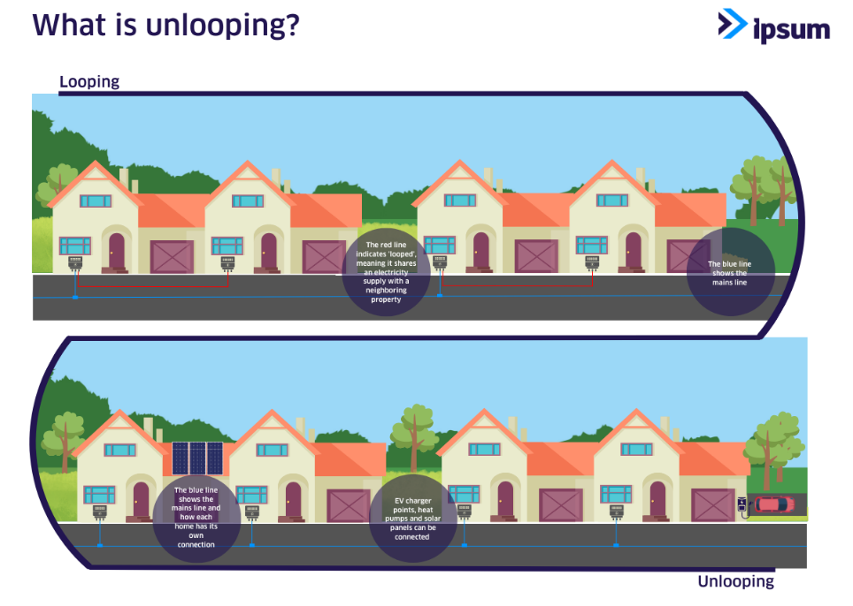

Electricity North West is taking a proactive approach and looking to improve the overall electrical resilience and performance of its network, while also future proofing it. This ensures properties are better equipped for future energy demands for example, electric car chargers, solar panels or heat pumps.

In 2019, the UK Government announced its ambitious Net Zero emissions by 2050 target. Upgrading electrical infrastructure through the likes of unlooping, plays a crucial role in supporting the transition to cleaner, more sustainable energy. This work will ensure homes can meet increasing electricity demands driven by the adoption of renewable energy and future heating solutions.

**What are the benefits of this work?**

The upgrade will provide long-term benefits including enhancing the reliability of your electricity and improving your properties energy efficiency. Homes with independent (unlooped) electrical supplies are more attractive in the housing market and often command higher prices due to reduced risk of supply disruptions or general shared supply issues.

While unlooping would typically come at a cost to residents, and is likely to in the future, it is being provided to your area free of charge.

Also, the project has a grant which will make contributions to local charity organisations close to residents' hearts. To find out more about this, contact us, on **[insert email address]**. Separately, Ipsum has also decided to fundraise and support local healthcare organisation, The Christie.

**An opportunity to ask questions**

On **[insert date]** at **[insert time]** we are offering you the opportunity to meet with project representatives and raise any questions / concerns. The community event will take place at **[insert location]** and will be attended by our Contract Director Gareth Hill, Community Liaison Officer George Glover, and Electricity North West’s **[insert title and name]**.

You can read more about Ipsum, Electricity North West, and the project on our website: <https://ipsum.co.uk/enw-unlooping/>.

We appreciate that in the coming months, the works may cause disruption or inconvenience for some residents, but please be reassured that we will try our upmost to minimise that where possible. If you have any questions or would like to discuss the project with our team, please don’t hesitate to reach out: **[insert email address]**. We look forward to meeting you soon.

Yours Sincerely,

**George Glover**  
Community Liaison Officer